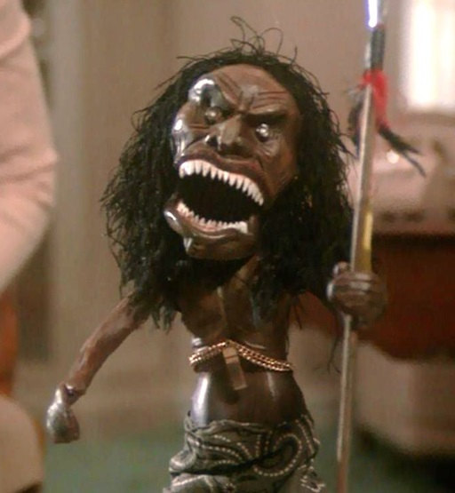
“Prey” by Richard Matheson
- What kind of archetype do we see Amelia pull out of the box?

- What are three clues from the first paragraph that foreshadow that this story may turn bad?

- What not-so-good thing has Amelia done during the phone call that could lead to bad things coming her way?

4. How does the phone call display psychological fear from Amelia?

5. Make a prediction about what will happen now that the chain has fallen off. Why do you think that will happen?

- On 325, when she says “It’s He Who Kills” and “He’s taken off his chain and gone--,” does she seem to be taking the missing doll serious? What tells you this? If she says it with the tone I imagine, what kind of irony is this?

- On 325 and 326, list at least three ways that Matheson builds suspense.

- “There was another sound. Amelia froze…No, she thought,” is an example of which type of fear?

- “Amelia jerked back, pulling up her legs…she gaped at it.” Now what kind of fear is she experiencing?

- What lesson has she learned when she closes the door to the bathroom?

- She whirled at the new sound, heartbeat leaping. Stepping to the door, she leaned down, listening hard. There was a faint metallic noise inside the knob.” What technique is the author using here? What would you do at this point?

- What archetypical mistake has Amelia made in the first paragraph on 330?

- In the first paragraph on 332, what technique is being used? What are 2 descriptions that tell you this is a pretty nasty bit of imagery?

- Make a prediction about how it will end after reading the second paragraph on 334.

- What type of irony does this story end with? Explain How it fits this type of irony.

- When thinking about the size of the doll, what type of irony is the fact that it pretty much dominated Amelia most of the story? How so?

17. How does “Prey” display a reestablishment of norms at the end? Consider the actions of the different characters throughout the story and the end result for them.

